A Short History of Winnie The Pooh: World War I, The Rolling Stones, and Maroon 5’s “Moves Like Jagger.”
Jerry Anderson March 18, 2016
It is bewildering how an event remembered for its violence and brutality coincidentally left us, as one of its most enduring legacies, a piece of innocence, joy, and fun which will exist in our collective cultural memory forever. World War I is the event in question that is still studied by historians today because of its monstrous and exorbitant death toll of at least nine million combatants, along with millions of additional civilian deaths. But how did this vicious conflict set the stage for the creation of the beauty, charm and delight I speak of?
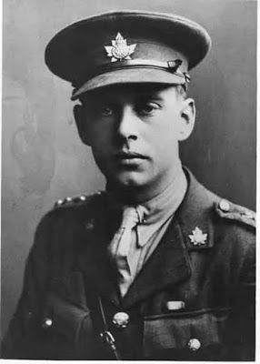
In 1914, at the outbreak of W.W.I, a man named Harry Colebourn from Winnipeg, Canada, and a number of his friends joined the armed forces of the British Empire and set off by train on the long eastward journey to the Atlantic coast of Canada where they would be shipped by boat to Europe to join in the fight.
NOTE: To encourage enlistments, the British Army developed a “buddy system” that allowed friends and/or men from the same town or community to join up together. They would remain in the same unit throughout training and into the fighting in Europe. This helped morale early on, but had disastrous consequences as the War progressed. Many communities suffered the loss of an entire generation of young men as the casualties and deaths mounted. Harry Colebourn and others from Winnipeg, Canada, had enlisted under this program.
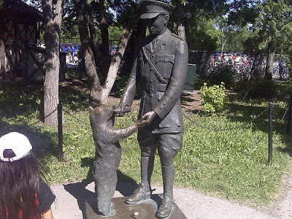
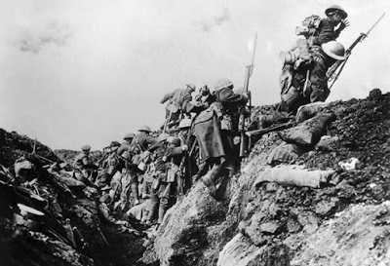
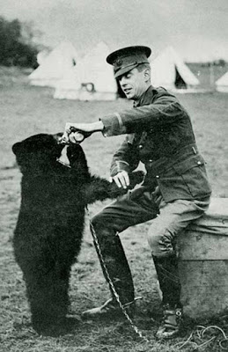
BACK TO THE STORY: As Lieutenant Colebourn and his men were waiting on a railroad station platform in the small town of White River, Canada, Harry looked down the platform and saw something that immediately caught his attention. Having been a veterinarian in civilian life, his eyes were naturally drawn to a man dressed in hunting clothes, standing, waiting, with a gun cradled in his right arm and, in his left arm, a small, female black bear cub. Harry approached the hunter and explained that he was a vet and asked for the story of how the cub came to be in the hunter’s possession. The hunter replied that he had killed the cub’s mother while hunting, unaware that the female bear had a cub nearby. Unable to leave the cub to die and, not knowing just what to do with it, he had picked it up in his arms and taken it with him out of the forest.
The statue erected in the town of White River, Manitoba, Canada, commemorating what happened next in the story.
Harry asked if he could have the cub, thinking that he and his men would adopt it as their mascot in the hope that it would bring them good luck. Anyway, he said, he was a vet and knew much about the care of animals. Who better to give the cub to? But the hunter was a cunning man and noted Harry’s interest, and hoping to make some money, he told Harry that he could have the cub if he wanted it,….but for the price of $20.00. Harry immediately produced the money and the cub was his. The cub was an instant sensation with the men in Harry’s unit. It wandered around the train, over and under the seats, and rummaged through the men’s baggage and military packs, getting into all kinds of mischief. The bear cub accompanied the soldiers on the troop ship that took them to England for training. It was said that the bear cub followed the soldiers around like a tame dog. Harry took the cub with him to many places he visited while in England, but their favorite place to visit was the London Zoo. Harry and the bear cub were a startling sight as he led her around on a leash while exploring London and surrounding areas. At night the bear cub slept underneath Harry’s bed in his unit’s barracks.
By the time that Harry’s unit was called to the front in France to fight in the war, a difficult decision had to be made. Harry Colebourn, now a Captain, knew that the trenches in the war zone were no place for a bear, so he took the young cub to the London Zoo and asked them to take care of it until he and his men returned from France. The zoo was overjoyed to have the bear cub on loan to them (there were no bears in the zoo at that time) and set up a special place for the little animal to live. Outside the bear’s cage a sign/plaque was erected giving the name of the resident bear within: “Winnie.” Harry and his fellow soldiers from Canada had named their mascot cub after their home town, Winnipeg, Canada.
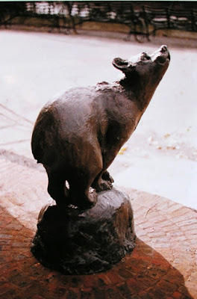
Statue of “Winnie” at the London Zoo. (present day) The statue was founded in 1981.
While Harry and his men went off to fight, the bear cub became a bigger and bigger bear and, finally, a full grown female black bear. She became one of the most popular exhibits at the London Zoo, especially for children, who eagerly came to see the curious, gentle animal. Harry visited Winnie whenever he got leave and was in London. He noted her growth and the delight she gave to the visitors she attracted. Harry survived the war and returned to the London Zoo in 1919 to see how his unit’s mascot was getting along. He found that the cub he had left years previously had now developed into a fully grown black bear, having become the center of interest for hundreds of children, and adults, who came to the zoo every day to see her. It quickly became evident to Harry that this was now “home” for the bear cub he had found on the railroad platform at White River almost five years earlier. In a formal ceremony in December, 1919, he gave the animal to the London Zoo where she would be taken care of and enjoyed by innumerable children in the years to come.
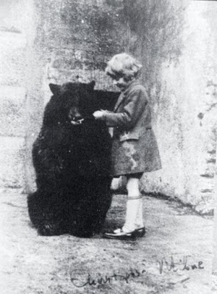
In the years that followed, many came to visit Winnie, but the most important to this story were a trio of individuals, two adults and one child. A.A. (Alan Alexander) Milne and his son (born in 1920) would often come to the London Zoo to see Winnie because she was his son’s favorite animal at the zoo. Reportedly, Milne’s son developed such an affection for the bear that he was allowed to spend time in its cage feeding it treats. He begged his father to take the bear home. Since this was impossible, Mr. Milne promised his son that he would write a series of bear stories for his son to enjoy.
Christopher Robin Milne in the enclosure at the London Zoo with “Winnie” the bear, feeding her treats.
NOTE: Historians say that it was a common sight for people to see “Winnie” giving children piggy back rides around the London Zoo and eating treats from their hands.
With them often came an artist and friend of the family named Mr. E.H. Shepard. Milne’s son often brought along his own stuffed bear named “Edward” to show to Winnie and, one day, he decided to rename his stuffed bear “Winnie the Bear.” Thinking the name much too commonplace, he decided to rename the bear “Pooh”, after the name of his favorite swan on his father’s estate outside London. Thus it was that the name “Winnie the Pooh” was created.
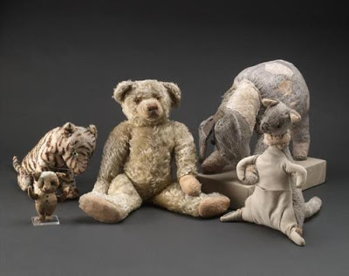
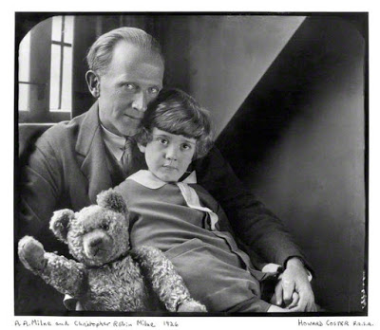
Mr. Milne was a noted writer of considerable talent and, as the promised gift for his son, he began writing fascinating and entertaining stories about “Winnie the Pooh” and a young boy named Christopher Robin. He asked his friend Mr. Shepard, an artist, to provide some pencil drawings of the characters to accompany the stories. Christopher Robin Milne was thoroughly delighted and enchanted to find himself a central character in the imaginative world created by his father and Mr. Shepard.
A,A. MIlne, Christopher Robin and Edward the Bear, soon to be renamed “Winnie the Pooh.” (photo taken 1926)
The adventures brought into being by his father included characters based upon the many stuffed animals found in the playroom of the young boy. Other characters, such as Owl and Rabbit, were based upon the animals found in the surrounding woods of the family estate, Cotchford Farm. Others were just imagined or made up.
Individually or in a group of 2-3, write your own “Winnie the Pooh” style short story that has a clear moral/life lesson and a history theme.

