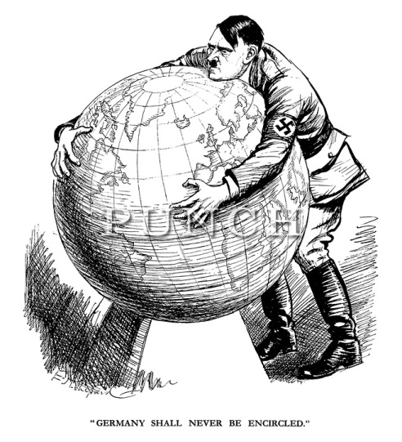
Political Cartoon Analysis (10 points)
Directions:
1. Find a political cartoon relating to one of our 7th grade units of study:
- America Becomes a World Power (Spanish American War)
- World War I
- The Russian Revolution
- America from the 1920s to the New Deal
- World War II
- Geography of the United States
2. Analyze the cartoon – turn in the cartoon and a complete description answering the following prompts. English conventions count.
a. Identify the cartoon by author, date of publication and name of publication.
b. Explain the point of view of the cartoon. (What message is the author attempting to convey)
c. Provide a detailed explanation of how the issue in the cartoon relates to the area of study from
above.
Note: You may not find a cartoon that is directly related to a topic of study. (i.e. it may be difficult to find cartoons on the Great Depression, but you may find a cartoon related to economic issues such as: a government’s role in the economic system, poverty, social security, etc. You will need to be creative in your thinking. What is important is linking with the concepts we have studied, not necessarily the exact same topic.)

Political Cartoon Analysis (10 points)
Directions:
1. Find a political cartoon relating to one of our 7th grade units of study:
- America Becomes a World Power (Spanish American War)
- World War I
- The Russian Revolution
- America from the 1920s to the New Deal
- World War II
- Geography of the United States
2. Analyze the cartoon – turn in the cartoon and a complete description answering the following prompts. English conventions count.
a. Identify the cartoon by author, date of publication and name of publication.
b. Explain the point of view of the cartoon. (What message is the author attempting to convey)
c. Provide a detailed explanation of how the issue in the cartoon relates to the area of study from
above.
Note: You may not find a cartoon that is directly related to a topic of study. (i.e. it may be difficult to find cartoons on the Great Depression, but you may find a cartoon related to economic issues such as: a government’s role in the economic system, poverty, social security, etc. You will need to be creative in your thinking. What is important is linking with the concepts we have studied, not necessarily the exact same topic.)

