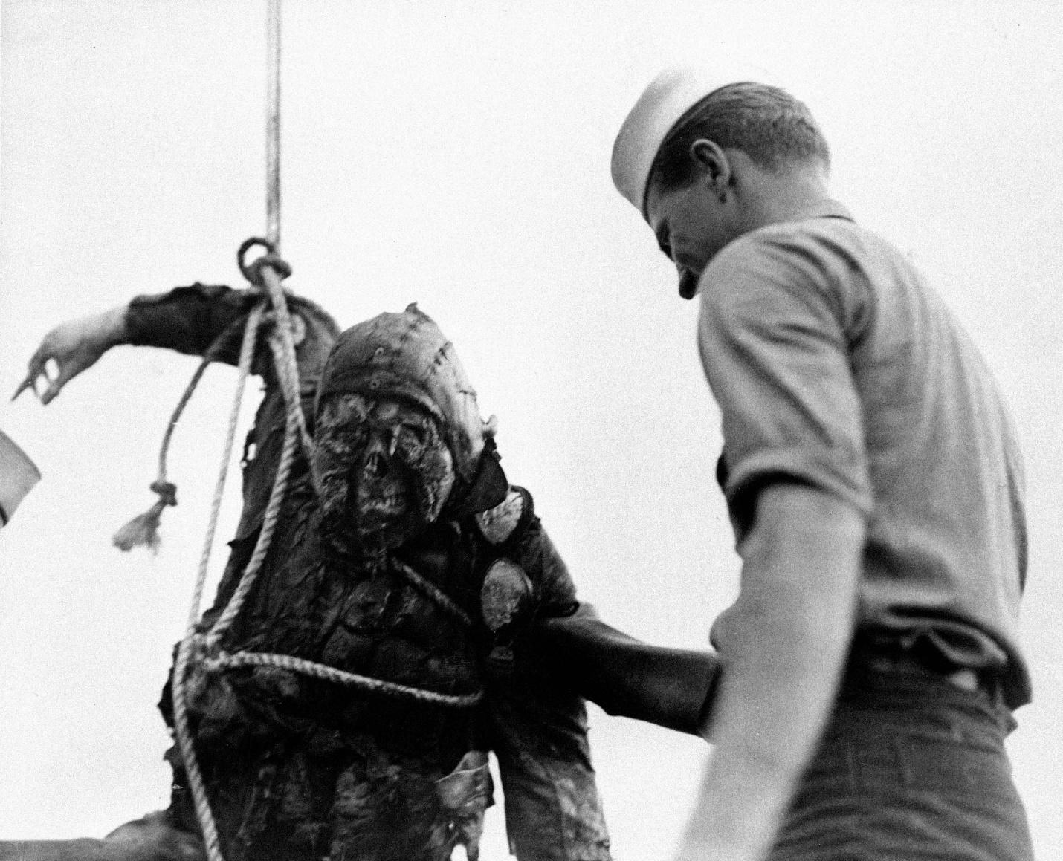
An American Seaman looks at the charred corpse of a Japanese flier brought up from the bottom of Pearl Harbor where he crashed with his burning plane during the Japanese attack on Dec. 7, 1941 in Hawaii.

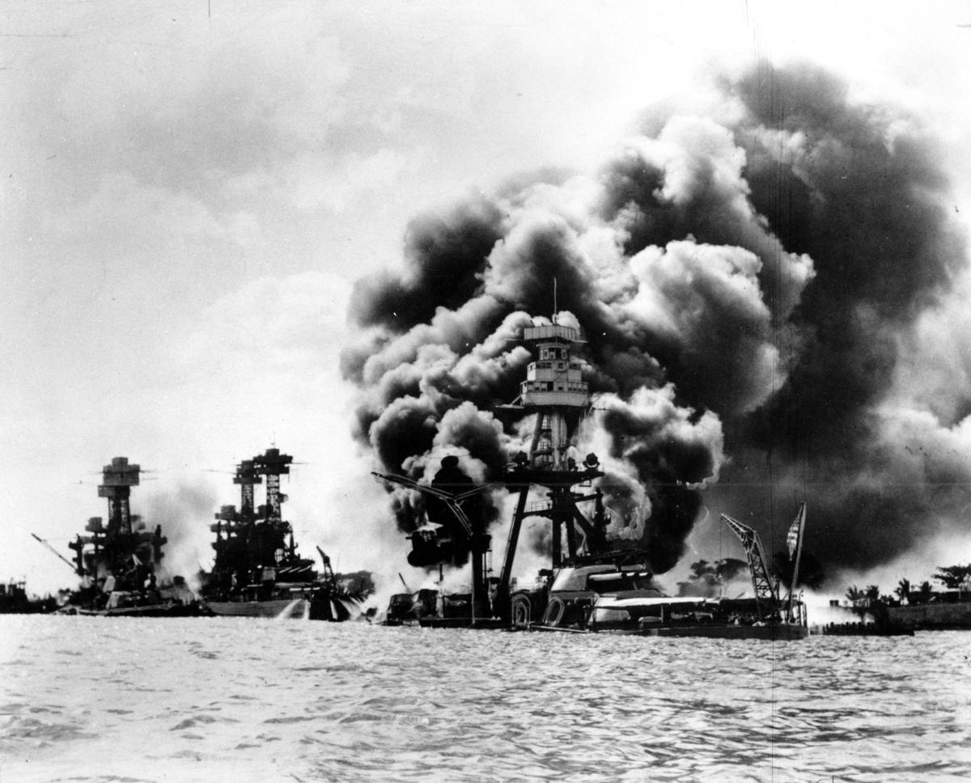

Three U.S. battleships are hit from the air during the Japanese attack on Pearl Harbor on Dec. 7, 1941. Japan's bombing of U.S. military bases at Pearl Harbor brings the U.S. into World War II. From left are: USS West Virginia, severely damaged; USS Tennessee, damaged; and USS Arizona, sunk.
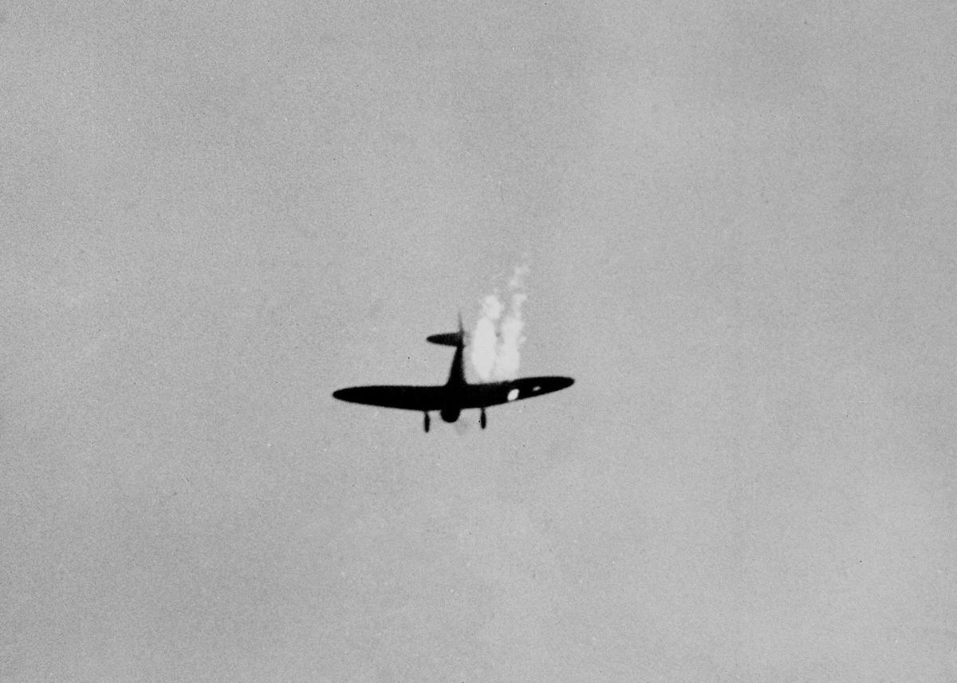
Japanese dive bomber goes into its last dive as it heads toward the ground in flames after it was hit by Naval anti-aircraft fire during surprise attack on Pearl Harbor, Dec. 7, 1941.
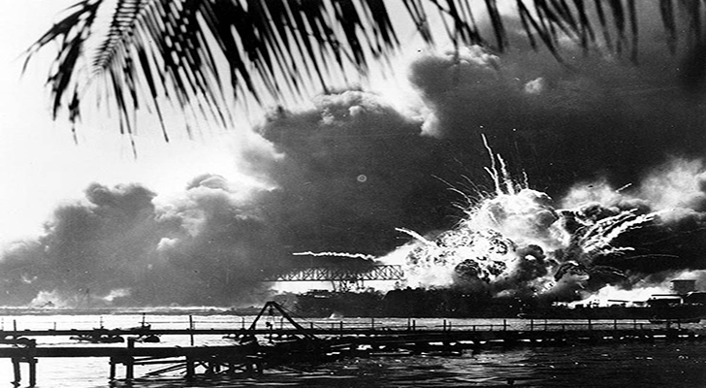

The destroyer USS Shaw explodes after being hit by bombs during the Japanese surprise attack on Pearl Harbor, Hawaii, on December 7, 1941.

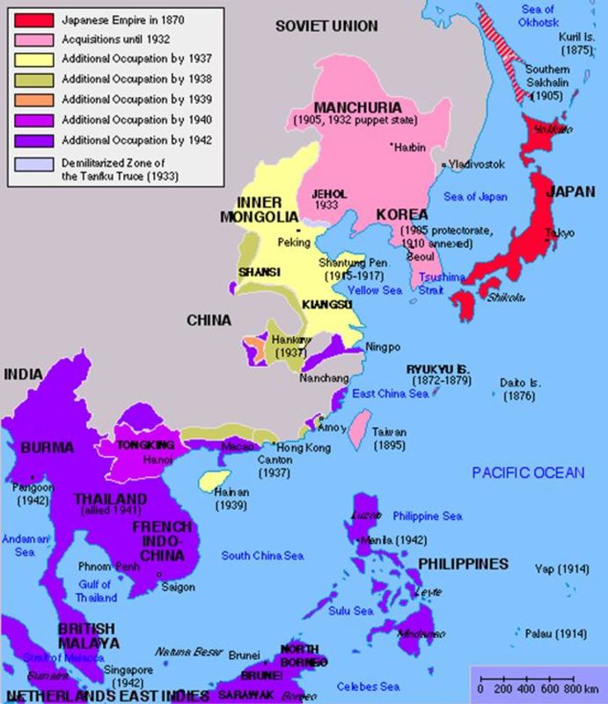
The Japanese Empire, 1870-1942

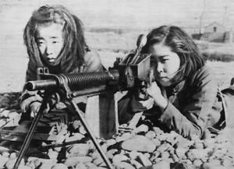

Japanese Girls Train with Machine Gun WWII
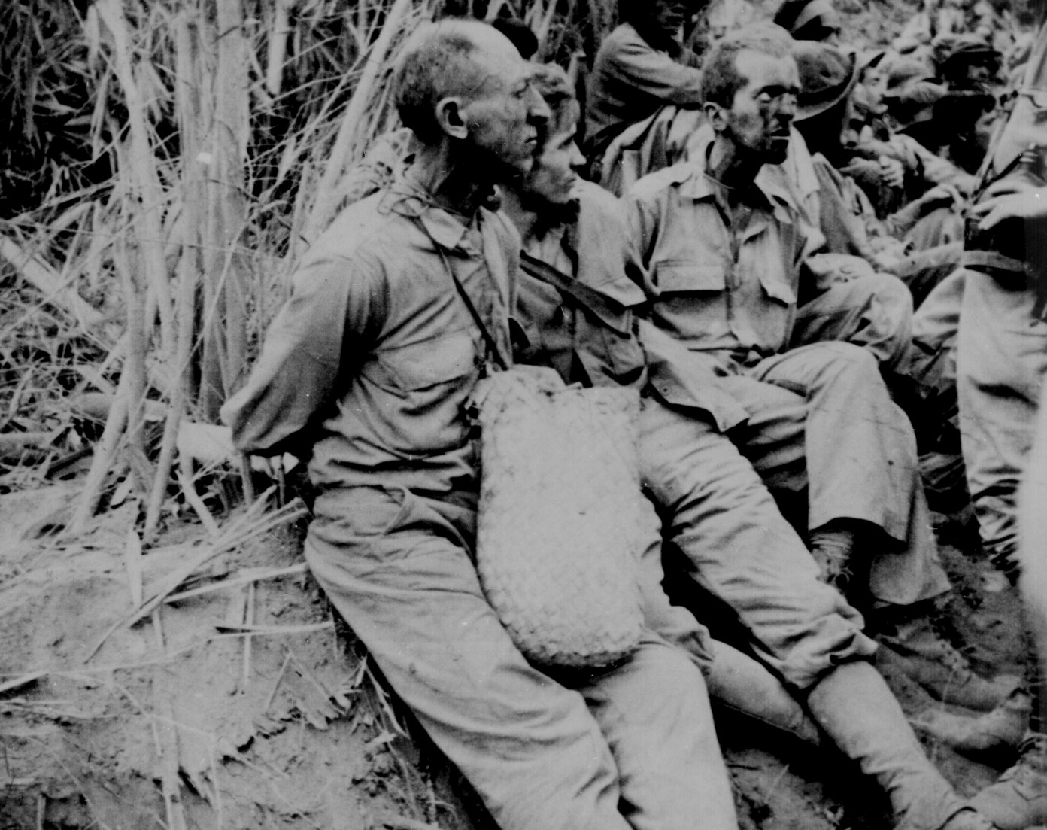

Along the March [on which] these prisoners were photographed, they have their hands tied behind their backs. The March of Death was about May 1942, from Bataan to Cabanatuan, the prison camp.
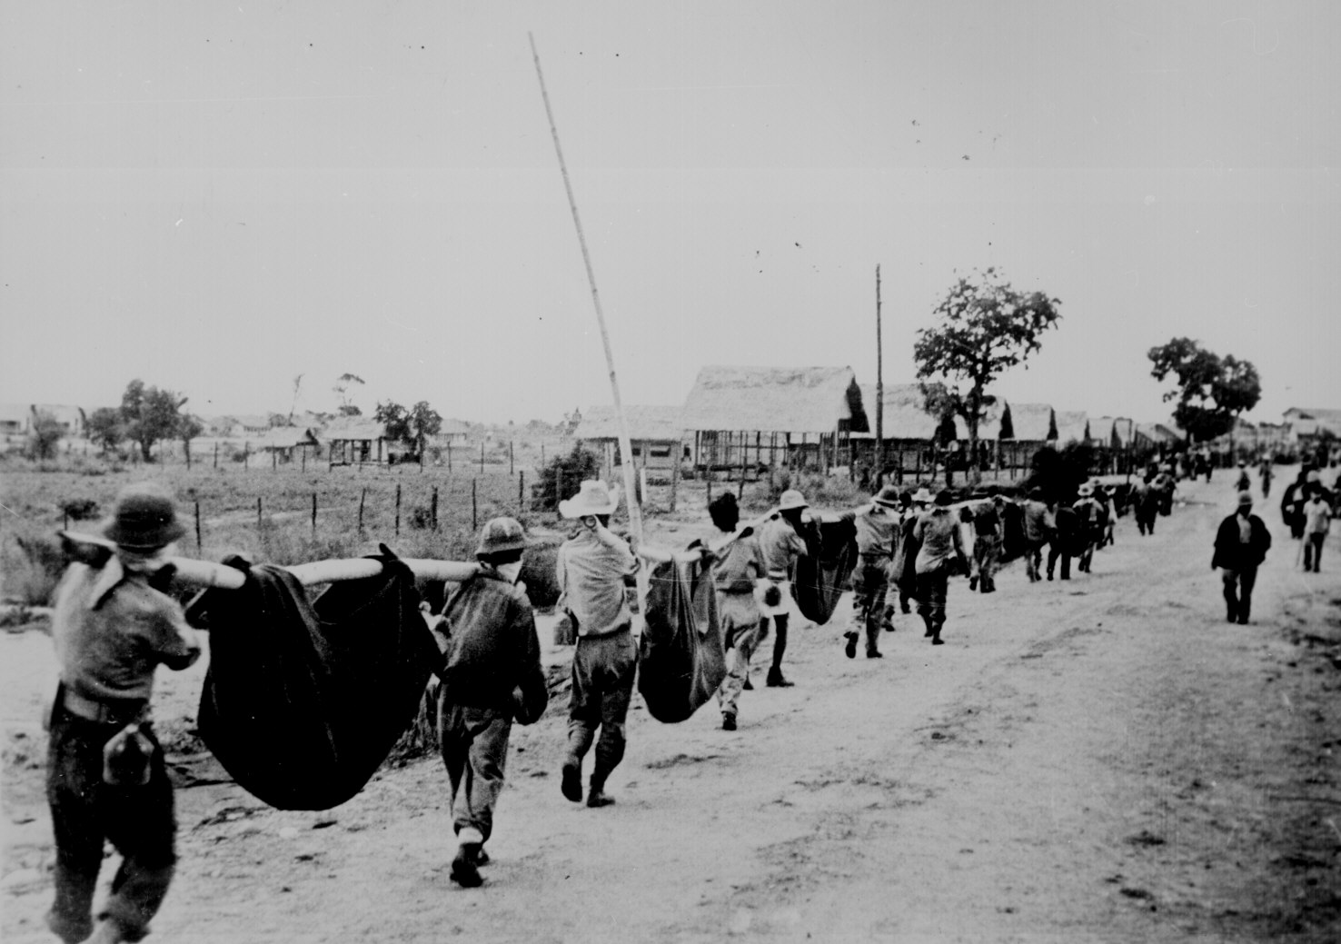

This picture, captured from the Japanese, shows American prisoners using improvised litters to carry those of their comrades who, from the lack of food or water on the march from Bataan, fell along the road. Philippines, May 1942.

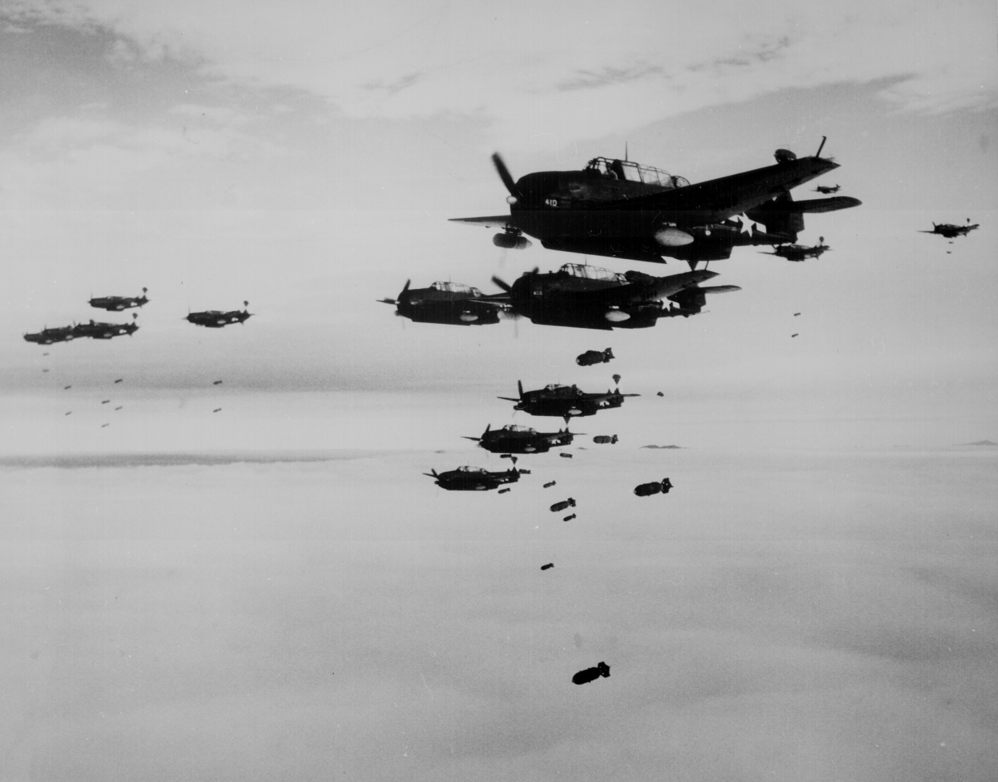
USS ESSEX based TBMs and SB2Cs dropping bombs on Hokadate (Hakodate), Japan. July 1945

