Name ________________________

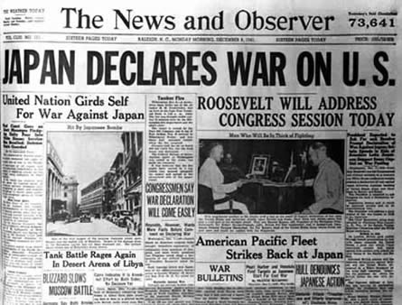 **Causes of Pearl Harbor writing assignment**  
Using at least **2** concrete, specific reasons, predict the causes of the attack on Pearl Harbor, Hawaii by Japan. Why did Japan attack the United States? Use your knowledge from the textbook reading and the Rise of Japan lesson. Describe and fully explain your answer. Use complete sentences and correct English conventions (spelling, punctuation, grammar, capitalization). This should be a complete paragraph (claim, support, commentary, support, commentary, conclusion).   
  
___________________________________________________________________________________________  
  
_________________________________________________  
  
_________________________________________________

_________________________________________________  
  
_________________________________________________  
  
_________________________________________________

  
  
  
  
  
  
  
  
  
  
  
  
  
  
  
  
  
  
  
  
  
  
  
  


