Name_____________________
PREPARING FOR D-DAY (Normandy)
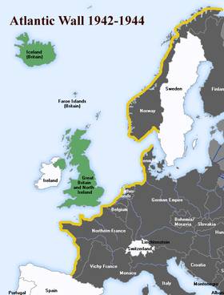
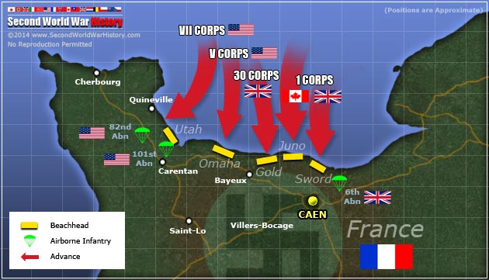
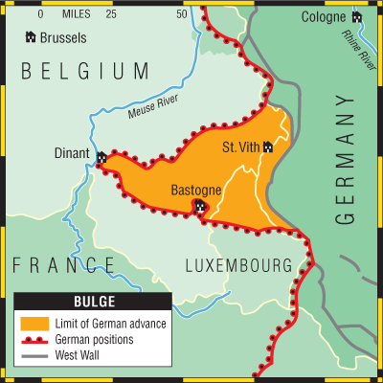
After WWII began, Germany invaded and occupied northwestern France beginning in May 1940. The Americans entered the war in December 1941, and by 1942 they and the British were considering the possibility of a major Allied invasion across the English Channel. The following year, Allied plans for a cross-Channel invasion began to ramp up. In November 1943, Adolf Hitler, who was aware of the threat of an invasion along France’s northern coast, put Erwin Rommel in charge of spearheading defense operations in the region, even though the Germans did not know exactly where the Allies would strike. Hitler charged Rommel with finishing the Atlantic Wall, a 2,400-mile fortification of bunkers, landmines, and beach and water obstacles.
In January 1944, General Dwight Eisenhower was appointed commander of Operation Overlord (D-Day). In the months and weeks before D-Day, the Allies carried out a massive deception operation intended to make the Germans think the main invasion target was Pas-de-Calais rather than Normandy. In addition, they led the Germans to believe that Norway and other locations were also potential invasion targets. Many tactics were used to carry out the deception, including fake equipment, a phantom army commanded by George Patton and supposedly based in England, across from Pas-de-Calais, double agents, and fraudulent radio transmissions.
A WEATHER DELAY: JUNE 5, 1944
Eisenhower selected June 5, 1944, as the date for the invasion; however, bad weather on the days leading up to the operation caused it to be delayed for 24 hours. On the morning of June 5, after his meteorologist predicted improved conditions for the following day, Eisenhower gave the go-ahead for Operation Overlord. He told the troops: “You are about to embark upon the Great Crusade, toward which we have striven these many months. The eyes of the world are upon you.”
Later that day, more than 5,000 ships and landing craft carrying troops and supplies left England for the trip across the Channel to France, while more than 11,000 aircraft were mobilized to provide air cover and support for the invasion.
D-DAY LANDINGS: JUNE 6, 1944
By dawn on June 6, thousands of paratroopers and glider troops were already on the ground behind enemy lines, securing bridges and exit roads. The amphibious invasions began at 6:30 a.m. The British and Canadians overcame light opposition to capture beaches codenamed Gold, Juno and Sword, as did the Americans at Utah Beach. U.S. forces faced heavy resistance at Omaha Beach, where there were over 2,000 American casualties. However, by day’s end, approximately 156,000 Allied troops had successfully stormed Normandy’s beaches. According to some estimates, more than 4,000 Allied troops lost their lives in the D-Day invasion, with thousands more wounded or missing.
Less than a week later, on June 11, the beaches were fully secured and over 326,000 troops, more than 50,000 vehicles, and some 100,000 tons of equipment had landed at Normandy. For their part, the Germans suffered from confusion in the ranks and the absence of celebrated commander Rommel, who was away on leave. At first, Hitler, believing the invasion was a maneuver designed to distract the Germans from a coming attack north of the Seine River, refused to release nearby divisions to join the counterattack. Reinforcements had to be called from further afield, causing delays. He also hesitated in calling for armored divisions to help in the defense. Moreover, the Germans were hampered by effective Allied air support, which took out many key bridges and forced the Germans to take long detours, as well as efficient Allied naval support, which helped protect advancing Allied troops.
In the ensuing weeks, the Allies fought their way across the Normandy countryside in the face of determined German resistance, as well as a dense landscape of marshes and hedgerows. By the end of June, the Allies had seized the vital port of Cherbourg, landed approximately 850,000 men and 150,000 vehicles in Normandy, and were poised to continue their march across France.
VICTORY IN NORMANDY
By the end of August 1944, the Allies had reached the Seine River, Paris was liberated, and the Germans had been removed from northwestern France, effectively concluding the Battle of Normandy. The Allied forces then prepared to enter Germany, where they would meet up with Soviet troops moving in from the east. The Normandy invasion began to turn the tide against the Nazis. A significant psychological blow, it also prevented Hitler from sending troops from France to build up his Eastern Front against the advancing Soviets.
The Battle of the Bulge
The Battle of the Bulge, fought over the winter months of 1944-1945, was the last major Nazi offensive against the Allies in WWII. The battle was a last ditch attempt by Hitler to split the Allies in two in their drive towards Germany and destroy their ability to supply themselves.
The Battle of the Bulge started on December 16, 1944. Hitler had convinced himself that the alliance between Britain, France and America in the western sector of Europe was not strong and that a major attack and defeat would break up the alliance. Therefore, he ordered a massive attack against what were primarily American forces. The attack is strictly known as the Ardennes Offensive, but because the initial attack by the Germans created a bulge in the Allied front line, it has become more commonly known as the Battle of the Bulge. Hitler’s plan was to launch a massive attack using three armies on the Allies which would, in his mind, destabilize their alliance and also take the huge port of Antwerp, Belgium through which a great deal of supplies was reaching the Allies.
Hitler believed that his forces would be able to surround and cut off Canada’s First Army, America’s First and Ninth Armies and Britain’s Second Army. On paper, it was a seemingly absurd plan – especially as Germany had been in retreat since D-Day, her military was depleted of supplies and was facing the awesome might of the Allies. However, Hitler, as commander-in-chief of the military, commanded that the attack should take place.
The battle started with a two hour bombardment of the Allies’ lines and was followed by a huge armored attack with the majority of the German armored-might based at the Schnee Eifel. The Germans experienced great success to start with.
Ø The Allies were surprised by the attack. They had received little intelligence about the coming attack.
Ø Before the attack started, English speaking German soldiers dressed in American uniforms went behind the lines of the Allies and caused havoc by spreading misinformation, changing road signs and cutting phone lines.
Ø The weather was also in Hitler’s favor. Low cloud and fog meant that the superior air force of the Allies could not be used.
However, the success of the Germans lasted just 2 days. Despite punching a bulge into the Allies front line, the Germans could not capitalize on this. The Germans had based their attack on a massive armored onslaught. However, such an attack required fuel to maintain it and the Germans simply did not possess such quantities of fuel.
By December 22nd, the weather started to clear, thus allowing the Allies to bring their air power into force and on the following day, the Americans started a counter-attack against the Germans.
On Christmas Eve, the Allies experienced the first ever attack by jet bombers. 16 German ME-262’s attacked rail yards in an attempt to upset Allied supply lines. However, without fuel for their armored vehicles, any success in the air was meaningless. The Germans had advanced 60 miles in two days but from December 18 on, they were in a position of stalemate. The fighting was ferocious. The New Year’s period was a time of particularly intensive fighting as the Germans attempted to start a second front in Holland. This time in the Ardennes coincided with a period of intense cold and rain and the soldiers on the ground faced very difficult conditions. Trench foot was a common problem for infantrymen, as was exposure.
By mid-January 1945, the effect of lack of fuel was becoming evident as the Germans had to simply abandon their vehicles. The 1st SS Panzer Division had to make their way back to Germany on foot.
The Battle of the Bulge was the largest battle fought by the Americans in WWII. 600,000 American troops were involved in the battle. The Americans lost 81,000 men while the Germans lost 100,000 killed, wounded and captured.

