Chronicle of Conflict 8-2
Suez Crisis: Nasser Nationalize the Suez Canal
By: Leighla and Maren

On July of 1956 the second Egyptian president, Gamal Abdel Nasser Hussein, opened up the Suez Canal to the world for public use. He believed that the canal could be used for more than just commercial shipping, but also to charge tolls to help pay for the Aswan Dam on the Nile River. He considered this to be his answer to the west for refusing to open the dam. The day the Suez Canal was opened to the public was a triumphant day for Egypt, but the risks it took to get to this turning point were huge.  The Suez Canal officially opened in the year of 1869. It was originally owned by French organizations and the Egyptian government. Although, six years later, Egypt sold their part to Britain. During the Egyptian Revolution Gamal Along with Mohammed Naguib, set out to overthrow the current monarchy of Egypt who happened to be King Farouk. As soon as Gamal took power as president he supported the idea of pan- Arab nationalism and continued strengthen his position in society. That soon led to the Suez Crisis on October 29, 1956.  Under U.S.S.R and U.N pressure, British, French, and Israeli troops along with Egypt began to occupy the canal and push troops out to gain full power of the canal. After several months the others started their withdrawal from the war and left Egypt going solo. In March 1957, Egypt took full control of the Suez Canal and nationalized it to the rest of society. Even after all that, many still felt a grave concern over this power and prosperity.  The nationalization of the Suez Canal caused something the we know as the Suez Crisis. This was a huge deal in the Middle East because it made trading way more convenient as well as making the countries that did not gain privilege of the canal very frustrated. During the crisis The British lost their control over Egypt. This lead to them teaming up with France and then occupying the canal. This move was known as the Anglo-French action. They were quickly kicked out by American sponsors of the United nations and Egypt. In the end of it all the Egyptian leader, Nasser, emerged a hero for he had nationalized both the Egyptians and the Arabs. Though Israel did not gain rights to the canal the did end up regaining shipping rights in the Straits of Tiran. As goes for the British and  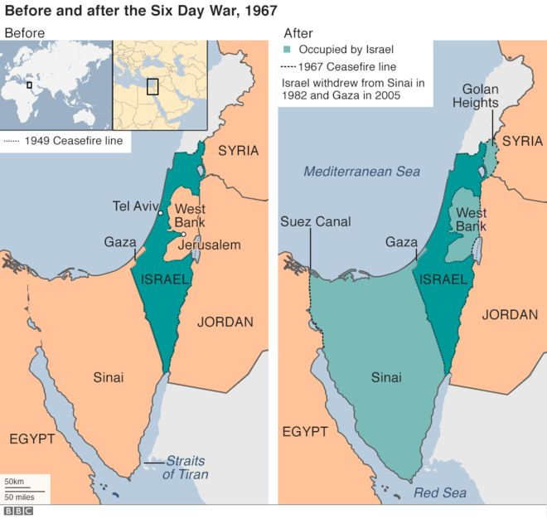  force inoperable and ensure that the Israelis maintained air superiority during the war. Run by Maj. general: Mordechai Hod, This air campaign consisting of 3 waves was arguably the largest reason that the war only lasted 6 days. In total, all but 12 of 300 operational Israeli jets were airborne and heading straight for Egyptian airfields. Exactly 472 Egyptian aircraft were destroyed and only 19 Israeli aircraft were shot down. All Israeli pilots ejected safely and were promptly rescued, leading to the largest success in air warfare history since the air battles in Vietnam since 1974. Aircraft used were F-4 Phantoms 1’s; Power houses capable of propelling these aircraft to speeds of 2,700 mph or known as mach 2.5 and armed with 8 missiles to tear down enemy fighter wings, Dassault 2000 Mirage’s; Maneuverable delta wing fighter aircraft with 4 missiles and a gun capable of tearing any aircraft from fighters to cargo planes into ribbons, and MiG 21’s; an old classic mach 2 interceptor from the Vietnam era armed with 2 missiles, 1 bomb, and a heavy cannon capable of dropping a bird in three gunshots. The 21 and F4 had seen combat against each other before but the F-4 had a trick up its sleeve. In 1962, the Israelis sent F-4 Phantom pilots to the Navy's fighter weapons school. More commonly known as TOP GUN. This program had one goal in mind for its pilots: to train the top one percent of pilots in the United States and the other air force capable Allied nations. Each Israeli member who graduated kill 12-27 enemy aircraft. In total, these pilots who graduated shot down 62 aircraft in total and became some of the best pilots in the world.  The Egyptian front was the largest front in the six day war and ensued the most casualties. Egypt started the war when it brought the two allies: Syria and Jordan to attack Israel. Egyptian leaders believed that if it's forces attack they could take back Jerusalem for the Muslims. Egypt put seven divisions on the front line, all of them were captured or destroyed. They saw Israel as a threat, and they knew that Israel would attack fist, which they did, with operation focus taking out most of Egypt’s air force allowing the Israelites to win the war. The Egyptians endured many losses, and their goal was to take over Israel, but they got to even touch foot into Israel. The Jordan’s and the Syrians were not much better, with both also enduring heavy losses, but not as much as Egypt.  Ever since Israel was established there had been conflict between Israel and Jordan. After the 1948 war, Jordan and Israel came close to a peace agreement, but not close enough. Part of this conflict lied in the fact that Jordan (as well as Syria and Egypt) was home to many Palestinian guerrilla groups. In 1966 Israel launched a massive raid into Jordan-occupied area. Hussein was outraged. He told the CIA that he had been in secret negotiations with Israel for years. In spite of what Hussein had said, the US supported a UN proposed solution to the conflict. Jordan was one of the |  | 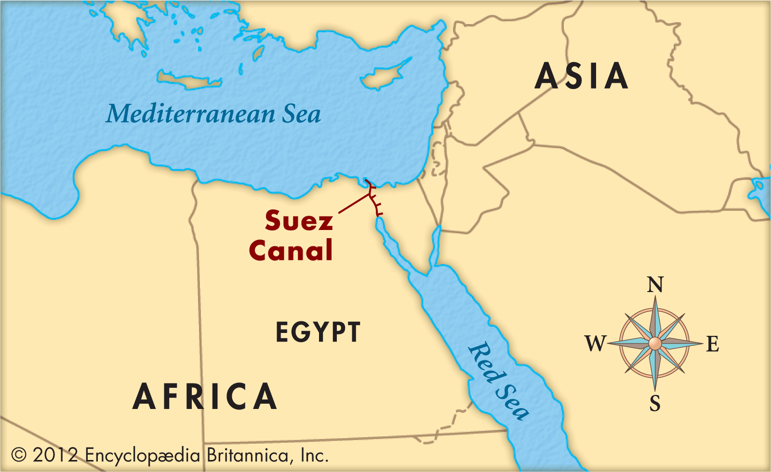  France, well they lost all influences in the Middle East. Several Years after the Suez Crisis Palestine started to seek liberation. They had been influenced by the Egyptians and the Arabs. The nationalization of the Suez Canal lead to a great deal of conflict but it was also just the kick off that the Middle East needed to start and rebuild their crumbling society. Before all of this happened the Middle East was like this big popular playground that everybody wanted for themselves. Members from the United Nations mostly, came into the middles east and started to gobble it up but the Suez Crisis put an end to all of that. Many countries started to seek independence. This eventually lead to terrorist organizations to form and take over as leader. There were many tensions between the Middle East and the West over this forming yet another much smaller scale cold war. This tensions lead to the Six Day War, and the Iran,Iraq War. Sixth day, Israel's enemies are devastated! By: Will Kelley, Leo Hamilton, Logan Pfaff, AJ Hennessy The sixth day of the fight between Israel and Egypt, Jordan and Syria has come to an end. When the attacks started on June 5 1967 Israel was prepared to fight. The three fronts each endured many battles, but Israel came out on top, only losing 800 of the 18000 lost in the six days of the brutal conflict. Before this political tensions were high, because of the difference in religion between Israel and the rest of the middle east, this meant that most of the middle east hates Israel and wanted it to become an Arab nation again instead of a Jewish nation. Many of the people that lived Israel were Arab, but there was a growing population of Jewish people in the country of Israel. The six day war was a fast war, but many died when it happened. Operation focus is one of the largest air campaigns conducted by the middle east. Its purpose was to render the Egyptian air  Arab nations that supported the Palestinian  conflict against Israel. In the times following  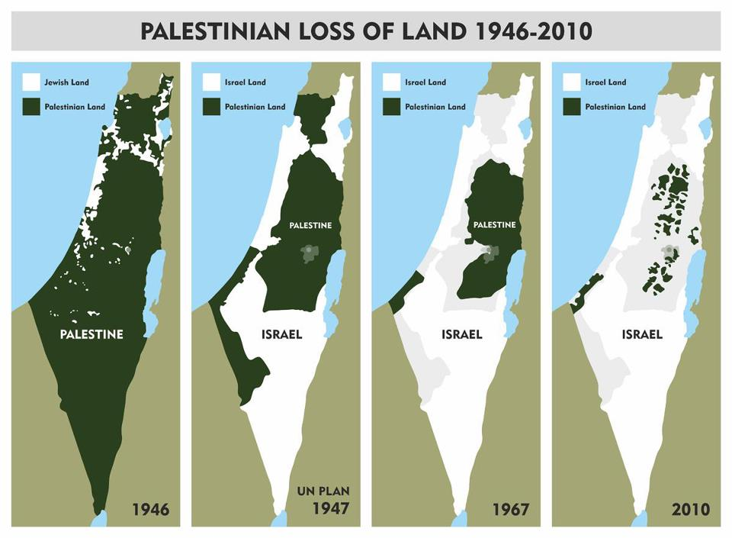  World War II, there was lots of conflict in  what is now Israel and Palestine. Two different  ethnic groups were fighting for dominance.  These two groups are Arabs and Jews. When  Israel was created in 1948, the surrounding  Arabs were shocked and angry. Conflicts  erupted the next day as the Arab-Israeli conflict  broke out. Long after this conflict ended,  tensions were still high. Just one week before  the conflict Jordan and Egypt agreed that in  the event of war, Jordan would prevent Israeli  forces from advancing instead of going on the  offensive. Just after the Israel air attack, the  Jordanian army began attacks on Israel.  The Jordans were a major part of the  Palestinian force. Although the Palestinians  had more forces, the Israelis emerged victories  with their further advanced training.  Israel went on a shopping spree of all the surrounding countries so that they would be recognized as a country themselves. The Israeli people did not want to be part of west bank. Even though west bank was very beneficial. The West bank was also under Palestine rule that is in Israel. Palestine that is a new Country that has had problems with Israel that has been affecting west bank because Israel wants it. Israel wants all the things Palestine owns including West bank. West bank has a lot of good resources. Like water, planting grounds, and mineral resources. Unlike the Gaza strip and West bank The Golan heights is under the rule of Israel.  The 6 day war was what put all this landforms under Israel's government. Israel took over the Gaza strip, West bank, and Golan heights (and many more).But in a way Israel got something then got the west bank and the Gaza strip taken away witch lead down a bloody path with Palestine.  The Gaza Strip is a small piece of land in between Israel and the Mediterranean sea. Gaza strip is under oppression by Israel because the Gaza strip has oil. And oil is very valuable to everyone and they need the benefit of trade (they need the money). So valuable that the US uses about 20.5 million barrels of oil per day. Which means the US really depends on oil. So Israel took that chance to get more business. Palestinians government is now ruling the Gaza strip but in Israel. Israel has conflict with Palestine about the Gaza strip. They had an agreement that they were truced for six months. That started more problems. They both were accusing each other about violations. And it has got worse after the truce broke .Three hundred were killed and 1,000 were homeless from the bombing this was after three weeks of the trusting breaking. And some of this was going on in west bank that was controlled by Israel. The Palestine populated area, west of the Jordan rive, is called West bank. But soon enough it will be entirely controlled by Israel.  Israel Occupies the West Bank, Golan Heights, and the Gaza Strip  By Carlie and Joy  The Golan Heights is a rocky highland a in south-western Syria, it has a political and strategic significance which contradict its size. The war lasted 2 days (the took over the last 2 days) of the 6 day war before Israel took over and relieved Golan from Syria. Syria began a failed attempt to reclaim Golan heights in 1973. When Israel took control of Golan it was bloody and violent, and used lots of air strike that hurt their enemies. Syria wants to get Golan Heights back as part of a peace deal. During US-brokered peace talks in 1999-2000. Israeli prime minister was willing to give back part of Golan to Syria. This all is related by the six day war.  The 6 day war was a bloody way for Israel to get what they want like the Gaza strip, west bank, and Golan heights. Palestine took things from Israel Witch created conflict and chaos.
SECONDARY PIECES

Quote: ¨Don’t be attracted to the easy paths, because the paths that make your feet bleed are the only way to get ahead in life.¨
-Saddam Hussein

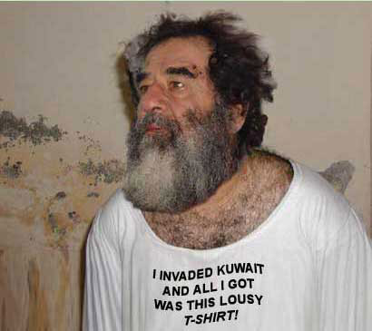
Saddam Hussein (المساهمة الثانية) Obituary – by Alec, Nicholas, Steinar

Saddam Hussein, age-69 lived-Baghdad, died-6:00 Dec 30th, 2006 Joint Iraqi Military base. He led Iraq as a country and most recently, against Iran. He was born a Sunni and… was always true to his... “beliefs”. For the most part even in death, he brought great joy to people. He served honorably as the fifth president/dictator of Iraq for twenty-four years. He was a lawyer, and graduated from Cairo Law School. He worked as a lawyer for many years in Egypt and Syria. Hussein also served Iraq as a defendant to the previous government, which allowed him the ability to rise to power. He directed Iraq’s oil industry too. He was also a high member of the Arab Socialist Ba'ath Party. He also wanted Iran for oil, so you can tell that his people came first. Hussein is Survived by his Daughters, Raghad Hala, Rana Hussein, and Sons, Uday and Qusay Hussein. Finally he is survived by his loving wife Sajida Talfah, his loving wife Samira Shahbandar, and his loving wife Nidal al-Hamdani. Accepting any ready to mourn at Joint Iraqi Military base this December for his public execution (open casket). Special thanks to Rauf Rashid Abd al-Rahman who made this whole event possible.

All other groups are missing their second contribution

Headline: The connection between Yom-Kippur War and the Israel Wars

Byline: Maddox and Jack

Lead paragraph: The Yom-Kippur began when the Arab coalition launched a joint surprise attack on israeli positions. The war began with a huge massive and successful Egyptian crossing of the suez canal. Then the Syrians then coordinated there attack on the Golan Heights to kind of a relation to Egypt. Then the Egyptian made offensive and initially made threatening gains into Israeli held territory. A Lot of this was from back then with other issues that carried on from the past to the future. Problems from the past can results in this case to war.

Explanation: The operation of the Egypt crossing was called Operation Badr this happened in 1973. It was about Egypt and its crossing of the Suez Canal and this attacked started the begin of the Yom-Kippur War. There opening attacks are known as The Crossing. The combat engineers used water cannons to break down the passages through the sand wall lining of the east bank canal and other armor. In addition to the canal crossing Egypt made a successful naval blockade against Israel in the Red Sea and the Mediterranean sea. A naval blockade is when trade from the Sea is cut off and all trade will be stopped.

BREAKING NEWS
Iran and Iraq are at it for seemingly no reason, it seems as if the senseless murder of these people is only due to the leaders’ hatred.

By: Steinar J, Alec D, Nicholas R.

Breaking News: Saddam Hussein surrenders Iran-Iraq war. His surrender was due to the cause of insufficient funds. Along with this cause, the members of the United Nations created Resolution 598, which forced an immediate ceasefire between the two countries. The war went rather out of hand, as Iran was beginning to use children to fight this war, and Iraq using advanced weapons. This war began in 1980 with Saddam Hussein having the need for more land. With that, conflict started brewing. The US ended up supporting Iraq. This war ended up with half of million casualties, and billions of dollars being spent. This war ended after eight years, and lasted longer than both world wars (WW1: 4 years, WW2: 6 years). Iraq tried to end this war sooner in 1982 with a ceasefire, but Iran refused, and war continued. Hussein surrendered because the United Nations created a resolution pressuring Iraq and Iran to create an immediate ceasefire. Both Saddam Hussein and the leader of Iran, Ruhollah Khomeini, hated each other with a passion, but there was much pressure on them to stop. With this, Iraq finally decided to initiate the ceasefire. Iran accepted shortly after, ending the war officially in July 1988. Reason for surrender was also due to the fact that Hussein was extremely unsuccessful in his attempts to gain land, as he only conquered approximately 0.31% of Iran.

All this war had come and gone in an instant. This sudden action was supposedly based on waterways, but there is good reason to believe that it was merely spite and greed for resources. Hussein thought that Iran would be a useful target due to it having much oil and supposedly being an easy target. Unfortunately for Iraq, Iran recently had a successful revolution against the Iranian monarchs, and had the strong feeling of nationalism, causing the fuel for them to fight back. Iraq used primarily chemical weapons for the war which Saddam Hussein was trying to use more of. In fact the use of these chemical weapons has caused Iran to ban the use of them entirely by any means.

This war is significant overall because it shows a good example about how two leaders’ hate towards each other can spark a huge conflict between them, and the citizens within the country. Such a lust for power can not only damage that person, but people around them. This also shows what a single person can do if they are given too much power. Iran used this power to their advantage by forcing their children to be on the front line, while Iraq used their power for their own personal gain (example: resources). The Iran-Iraq war leads directly into the Persian Gulf War because while Iraq was using their technological advancements to gain an advantage, they attacked third-country oil tankers that rested on the Persian Gulf. After the war, the exchange of prisoners was finally completed in 2003, 15 years post war.

BREAKING NEWS: PERSIAN GULF WAR COMES TO AN END
The Persian Gulf War lasted from 1990 to 1991; it all started when Saddam Hussein ordered the invasion of Kuwait hoping to get the oil reserves and fixing the huge debt Iraq owed to Kuwait. After that everything started to go by fast. On August 3 the NSC (National Security Council) asked Iraq to withdraw. August 8th the United States sent Air Force fighter planes to Saudi Arabia; other planes from NATO also arrived. After failed efforts to get Israel to withdraw Hussein made peace with Iran.
Saddam Hussein was born on April 28, 1937 and lived to December 30, 2006. Before He became President of Iraq he was a member of the Ba’th party. While he was a part of this group he tried to assassinate the Iraqi prime minister and failed. Because of this he fled to Syria and then to Egypt. In 1963 the Ba’th Party took power in Iraq but were overthrown that year and Saddam spent many years in prison. He escaped and became leader of the Ba’th Party. He also was in the group that overthrew the government and the Ba’th party went onto power again. Saddam got total control in 1980 and became president when Bakr resigned.
Two weeks after Hussein negotiated a peace treaty with Iran he made a speech accusing Kuwait of taking oil from the Ar- Rumaylah oil fields located on the border. He also accused Kuwait and Saudi Arabia of conspiring with Western oil- buying nations to keep oil prices low. To stir up the pot even more Iraq had started to send troops down to Kuwait’s border. Alarmed by these actions the president of Egypt (President Hosni Mubarak) initiated negotiations between Iraq and Kuwait to try to prevent other powers from getting involved. Hussein broke off from the negotiations after two hours and ordered the invasion of Kuwait. Hussein assumed the the other Arab states would stand by his side and not get other powers involved, but he was wrong. The President of the United States (George H. W. Bush), the governments of Britain, and the Soviet Union immediately condemned the invasion. On August 3 the United Nations called for Iraq to withdraw. Three days later king of the Saudi Arabians King Fahd met with the United States to request military assistance. On August 8th United States Air Force fighter planes started to arrive in Saudi Arabia as part of the military build up named Operation Desert Shield. In Kuwait Hussein built up his troops to 30,000. In an effort to gain support from the Muslim World Hussein declared a jihad (holy war).
On November 29, 1990, the U.N. security council ordered iraq to withdraw its forces from the shores of Kuwait by January 15th, authorizing the use of “any means necessary” to get them out. The Iranian government refused. On January 17th, 1991, the U.S. sent a massive air force to strike Iraq’s air defenses. It then swiftly moved on to hit other places of importance, such as communication networks, weapon plants, and oil refineries. The Iraq air force was destroyed, and the attacks left devastating results.
Because of this attack, and the iraqi resistance nearing a collapse, President Bush declared a ceasefire. Saddam Hussein reluctantly agreed to the peace terms in by which the U.S. had set forward. The terms outlined that Hussein and his forces must be rid of all the weapons of mass destruction and recognize Kuwait's sovereignty.

